Разработка урока по английскому языку к УМК М.З. Биболетовой «Английский с удовольствием» 6 класс.
Тема: «Путешествие в Лондон».
Подготовила: Мотина А.А., учитель английского языка
МБОУ СОШ №15 г. Королёва М.О.
Урок разработан по теме «Лица Лондона», который продолжает знакомство с достопримечательностями Лондона. Урок проводится в форме игры – путешествия, где на каждой станции учащиеся углубляют, развивают и дополняют свои знания о стране изучаемого языка.
Урок комплексного применения знаний, в котором взаимодействие между структурными элементами делает его многоцелевым и эффективным, имеет практическую направленность. Применение современных технологий формирует готовность и желание детей участвовать в межкультурном общении на изучаемом языке, развивает творческие способности и повышает познавательную активность учащихся.
Цель урока: формировать и развивать коммуникативную и социокультурную компетенции.
Задачи урока:
- Образовательные - совершенствовать навыки диалогической и монологической речи по теме: «Лондон»; актуализация лексических единиц.
- Развивающие – развивать память, мышление, воображение учащихся; развивать инициативу и самостоятельность; развивать навыки работы в парах и группах.
- Воспитательные – воспитывать чувство любви к родному краю, прививать интерес к стране изучаемого языка; воспитывать культуру общения.
Используемое оборудование: картинки с изображением достопримечательностей Лондона, CD – диски, магнитофон.
Тип урока: урок комплексного применения знаний (комбинированный).

Ход урока
I.Организационный момент. (Introduction). Сообщение темы урока.
Good morning, dear friends.
I am glad to see you.
We are having guests today.
Let’s greet them with a “Good morning”.
Today we are going to have an unusual lesson.
We have received an e-mail letter.
Our British friends have invited us to visit London.
(Звук самолета. Макет самолета)
Imagine we are on the board of the plane.
Today we are travelling to London. During our visit you will visit different sights, improve your knowledge and revise your favourite Present Perfect Tense.
Close your eyes!
Open your eyes!
Here we are.
(Учитель указкой показывает Лондон на карте)
На доске запись: Welcome to London!
- Фонетическая зарядка (Phonetic practice)
I want you to begin our journey from the first station “Sounds”. I am sure you like playing different games. Let’s play the “Echo” game.
(Учитель по строчке произносит стихотворение, а учащиеся только последнее слово)
Listen to the poem “Traveller”, be my echo and repeat only the last word.
Pussy-cat, pussy-cat [kᵆt]
Where have you been? [ bi:n]
I’ve been to London [lɅ n]
To look at the Queen [ kwi:n]
Pussy-cat, pussy-cat [kᵆt]
What did you do there? [ ]
I frightened a little mouse [maus]
Under her chair! [tʃɛə]

Teacher: Recite the poem all together once more.
Well done! Thank you!
- Речевая разминка (warm-up).
The next station is “Places of interest”.
Look at the blackboard.
You can see an aphorism.
Let’s read it and discuss what it means.
A world is a book
and if you do not travel
you read only one page.
Why is travelling important for us?
P1: It is interesting.
P2: We can see different countries and places of interest.
P3: We learn customs and traditions of these countries.
Teacher: They say “When a man is tired of London, he is tired of life”. Why do people want to visit London?
P1: London is a beautiful city.
P2: There are a lot of places of interest in London.
Teacher: Name some places of interest and show the pictures.
Учащиеся называют достопримечательность и соотносят с картинками.
Teacher: What can you show to foreign visitors in our city?
(The Space Mission Control Centre, the monument to S.P.Korolev, the St. Kosma and Domian Church).
What advertisements have you written for visitors to your city?
(2-3 ученика зачитывают объявления для посетителей нашего города)
Come to Korolyov and you will never forget your visit!
- Активизация лексических навыков.
Teacher: Our next station is “Brain Storming”
- Работа по учебнику с.83, упр.16.
Answer very quickly. Which place do you associate with the following things:
- Big Ben – the Houses of Parliament
- London Zoo – Regent’s Park
- Peter Pan – Kensington Gardens.
- Учебник с.85, упр. 23.
Station “Signs”.
When you arrive in London you have to know all the signs not to get lost in the city.
Your task is “match the signs with their descriptions”.
- Физкультминутка (Physical activities).
“Rest” Station
It is time to have a rest. Will you, stand up. Let’s remember the poem about London and do some exercises. Will you repeat after me. Pavel, help me, please. (Ученик делает упражнение перед классом)
- Up, down, up, down. (поднимаем руки вверх и опускаем)
- Where is the way? (разводим руки в стороны)
- To London town (руки перед собой)
- Where? Where? (поворачиваем в стороны)
- Up in the air. (смотрим по сторонам)
- Close your eyes (закрываем глаза)
- And you are there! (открываем глаза)
Teacher: Thank you. Take your seats.
- Совершенствование навыков диалогической речи. Работа в парах. Проверка домашнего задания. (It is time to check your home task)
If you were in London, what places of interest would you like to visit?
You must prove they are worth seeing and visiting.
Make up a dialogue. Work in pairs. Consult each other and in 2 minutes we will listen to your dialogues.
One pupil is a guide, the second pupil is a visitor. Now act out the conversation between G and V. Who would like to start?
Guide: Hello. My name is…..
I am your tour guide today. Have you ever been to London?
V: No, I haven’t.
G: I hope you will enjoy your stay here. Where would you like to go first?
V: I would like to visit Madam Tussauds. Is it worth seeing and visiting?
G: Yes, certainly. No visit to London would be complete without visiting it. Madam Tussauds is the famous waxworks museum. It is full of wax models of famous people. It is worth seeing. Do not miss it out!
V: OK. Let’s go then!
Teacher: Давайте по длительности аплодисментов определим лучший диалог. Clap your hands!
- Совершенствование навыков монологической речи. Групповая работа. (Приложение 1)
Ex.17, p.83. Station “London”.
- Will you open your books, p.85, ex.24.
- Let’s read the phrases.
- Which of the following phrases do you think best prove the fact that London is worth visiting? Why?
- Let’s work in groups of four. Let’s arrange 3 groups. Each group will have one statement. Give your examples, give your opinions and share your ideas.
Ученики делятся на 4 группы. Каждая группа получает одно утверждение из упражнения.
The task is to add your ideas and examples to the following statements concerning the topic “London”.
Ученики работают в группах в течение 4 минут. Затем один ученик из каждой группы представляет рассказ, а члены группы могут помогать ему и дополнять.
- Задание на дом.
Station “The Best Story”.
It was very interesting to listen to your stories about London. We shall continue our discussion next time.
Your home task is to prepare a story about London. You will take part in a competition and at the next lesson we will choose the best story and a teller. Write and make a design for your story.
- Контроль полученных знаний.
The next station is the “Quiz”. (Приложение 2)
Now we have to revise the information about London. Let’s work in groups of four. Do London Quiz and check yourself using the key answers. You have 5 minutes. Take your time!
- Итог урока (Summing up)
The Station “Again at home”.
So, there are so many other places to see and visit in London. However, the trip is very short.
(звук самолета)
We are at home now!
Did you like your trip to London?
Would you like to visit London in real life? (Give full answers)
(The trip was very interesting and we would like to visit London a lot).
We have worked hard today.
You were active, polite and friendly.
Thank you for your good work.
Your marks are only excellent.
- Рефлексия
Here you can see different smiles. I would like to know if you liked the lesson.
Happy OK so-so

- The lesson is over. You have been very attentive. Hope you enjoyed the lesson too. Good bye, students!
- (Good bye. Thank you!)

Приложение 1.
London Sightseeing Tour

1.London is the ______________________ .
2.It is a _____________________________ .
3.London is worth____________________ .
4.Welcome to ________________________!
5. Do not miss your ___________________!

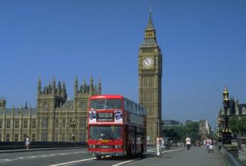

London Sightseeing Tour

6.There are a lot of __________in London.
7. Most museums are ________________.
8. Madame Tussauds is ______________.
9. In MOMI ________________________.

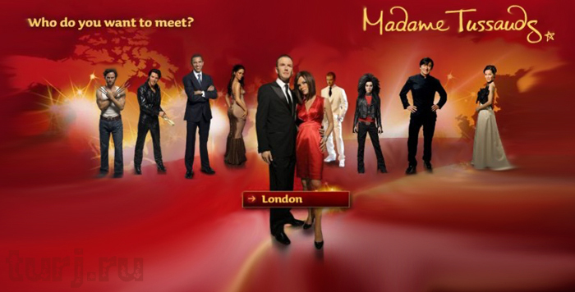

London Sightseeing Tour

10. Londoners are proud of ___________.
11. Hyde Park is famous for __________.
12. Regent s Park is a home of ________.
13. ______ can be seen in ______ gardens.

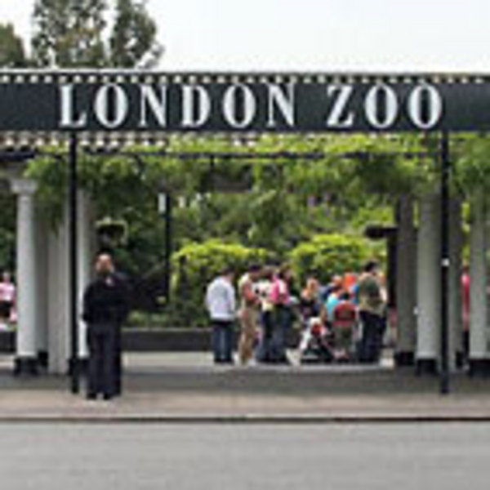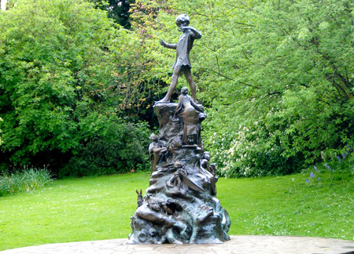

QUIZ : Do you know London?

1. What is the symbol of England?
2. What is the main clock?
3. What is the Tower now?
4. Who speaks in the Houses of Parliament?
5. Where can you see the largest collection of wax life – size figures of famous people?
6. Where is the history and magic of the cinema and TV explained?

Keys:

1. Westminster Abbey
2. Big Ben
3. a museum
4. country’s leaders
5. Madame Tussaud’s museum
6. MOMI

